MATHEMATICS II 2026 SEED MOCK PROVISIONAL Marking key (PAPER II)
- (a) 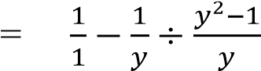
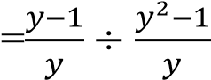
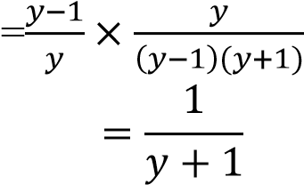

(b) 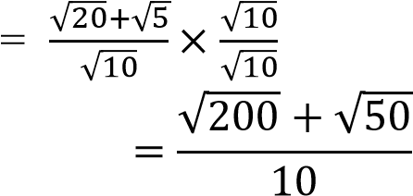

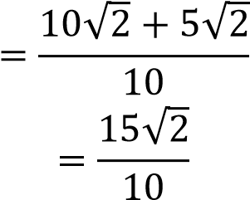

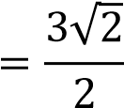

- (a) 𝑠_{𝑛} = 3𝑛² + 2𝑛
𝑠1 = 3(1)² + 2(1) = 5
𝑠2 = 3(2)² + 2(2) 16
𝑠3 = 3(3)² + 2(3)33
𝑆𝑛 = 5, 16,33
𝐴𝑃: 5, 11, 17 … ..
𝑑 = 11 − 5
= 6
(b) Modal class = 31 − 41
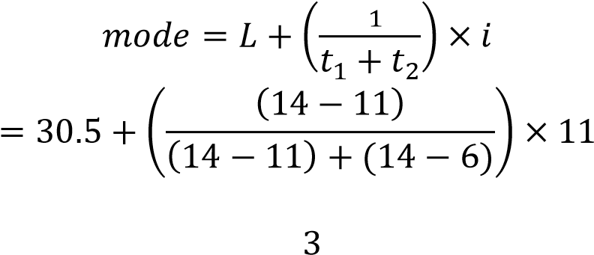𝑡

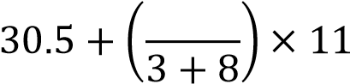

30.5 + 3

= 33.5

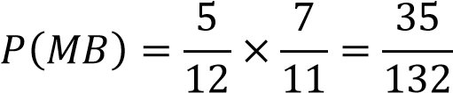
- (a)

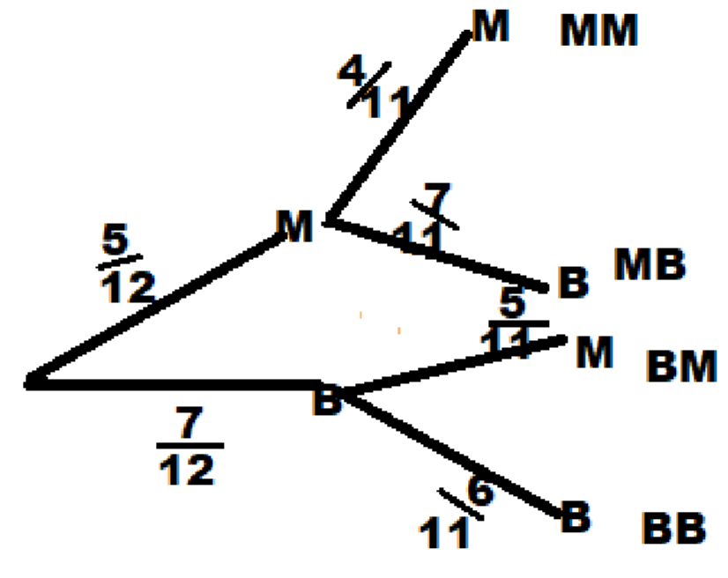

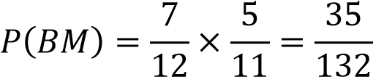
P (mango and Banana) =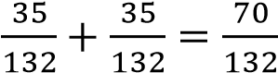
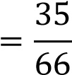
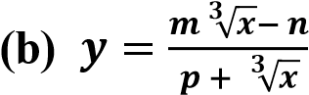
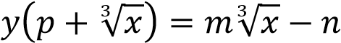
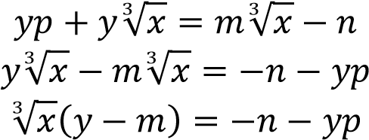
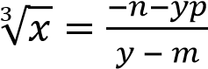
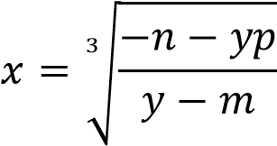

- (a)
- angle 𝐵𝐴𝐸 = 90 ⁰(𝑟𝑎𝑑𝑖𝑢𝑠 ⊥ 𝑡𝑎𝑛𝑔𝑒𝑛𝑡)
𝑎𝑛𝑔𝑙𝑒 𝐵𝐶𝐴 = 90⁰((𝑟𝑎𝑑𝑖𝑢𝑠 ⊥ 𝑡𝑎𝑛𝑔𝑒𝑛𝑡
𝑎𝑛𝑔𝑙𝑒 𝐵𝐴𝐸 + 𝑎𝑛𝑔𝑙𝑒 𝐵𝐶𝐴 = 180
Therefore, ABCE is cyclic
- Join BD, BE,AC
ABCE is cyclic (proven)
𝑎𝑛𝑔𝑙𝑒 𝐶𝐵𝐸 = 𝑎𝑛𝑔𝑙𝑒 𝐶𝐴𝐸(𝑠𝑎𝑚𝑒 𝑠𝑒𝑔)
𝑠𝑖𝑛𝑐𝑒 𝑎𝑛𝑔𝑙𝑒 𝐶𝐴𝐸 = 𝑎𝑛𝑔𝑙𝑒 𝐴𝐵𝐷(𝑎𝑙𝑡 𝑠𝑒𝑔)
∴ 𝑎𝑛𝑔𝑙𝑒 𝐴𝐵𝐷 = 𝑎𝑛𝑔𝑙𝑒 𝐶𝐵𝐸

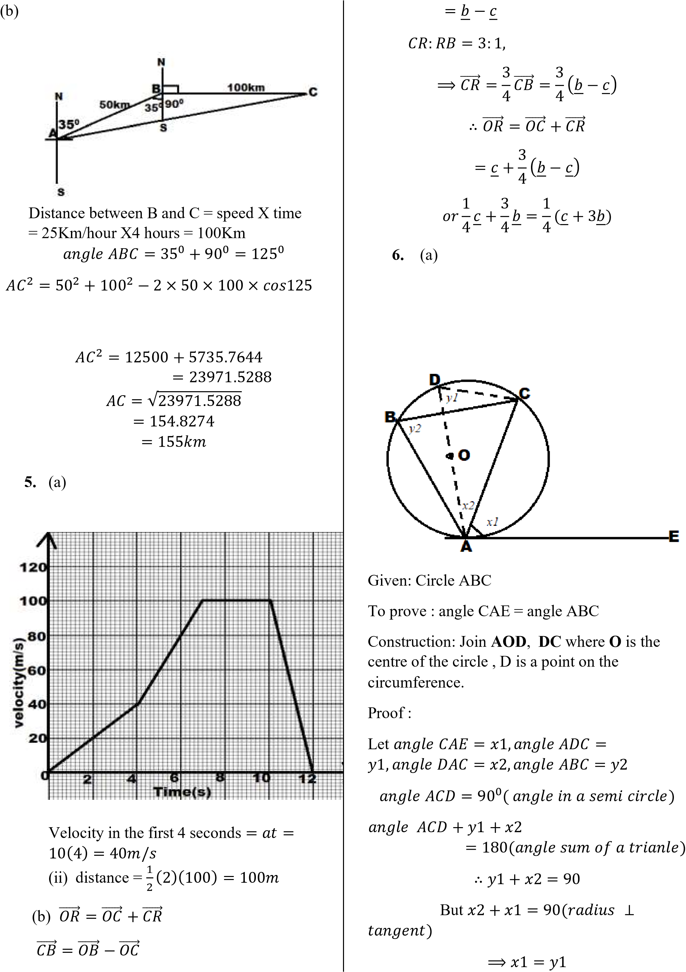
Since 𝑦1 = 𝑦2(𝑠𝑎𝑚𝑒 𝑠𝑒𝑚𝑒𝑛𝑡)
∴ 𝑥1 = 𝑦2
∴ 𝑎𝑛𝑔𝑙𝑒 𝐶𝐸𝐴 = 𝑎𝑛𝑔𝑙𝑒 𝐴𝐵𝐶
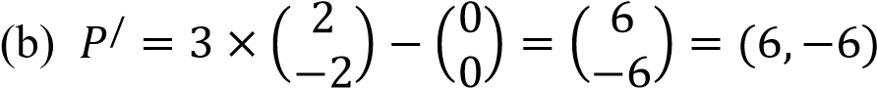
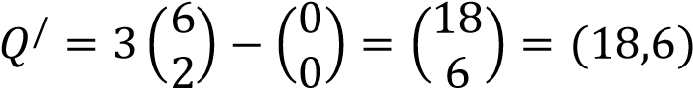
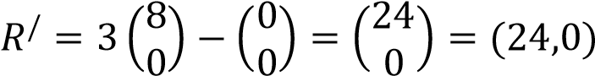

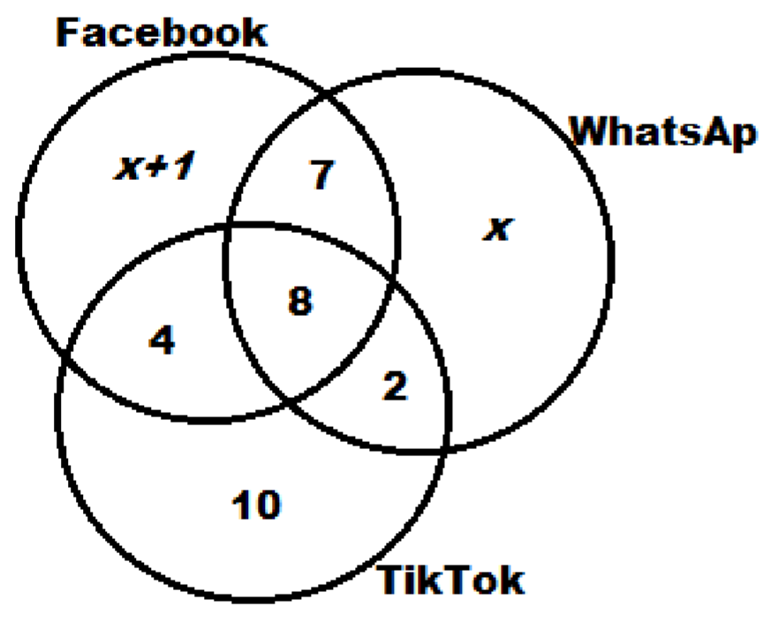
(b) 𝑥 + 1 + 7 + 𝑥 + 8 + 4 + 2 + 10 = 40
  - 2(−)³ − 5(−1)² − 4(−1) + 3 2𝑥 + 32 = 40
−2 − 5 + 4 + 3 𝑥 = 4
⁰⁼ Face book = 𝑥 + 1 + 7 + 8 + 4
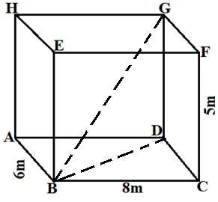
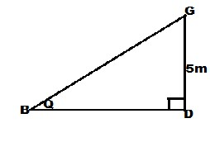
(𝑚 + 1) is a factor. 4 + 1 + 7 + 8 + 4 = 24 𝑝𝑒𝑜𝑝𝑙𝑒.

𝐵
𝐷
2
=
8
2
+
6
2
=
100
𝐵𝐷
=
√
100
=
10

𝑡𝑎𝑛𝜃
=
5
10
=
0
.
5

𝜃
=
26
.
5651

=
2
7
0

9.
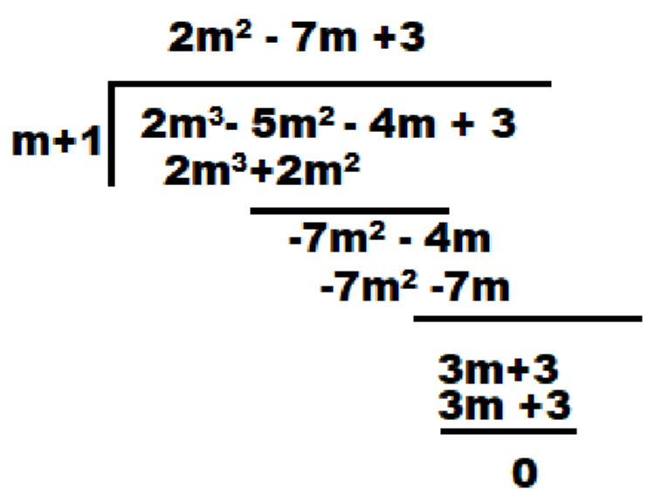
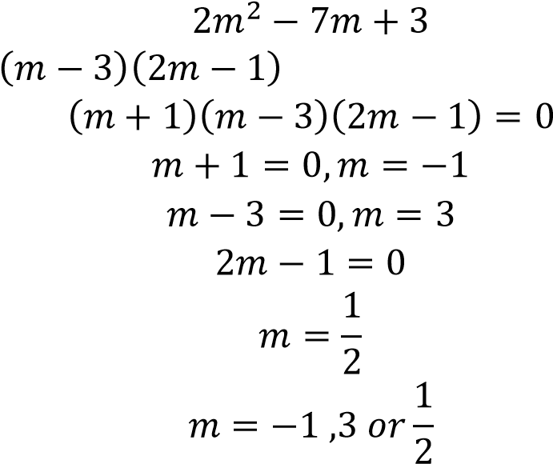

  - (b)

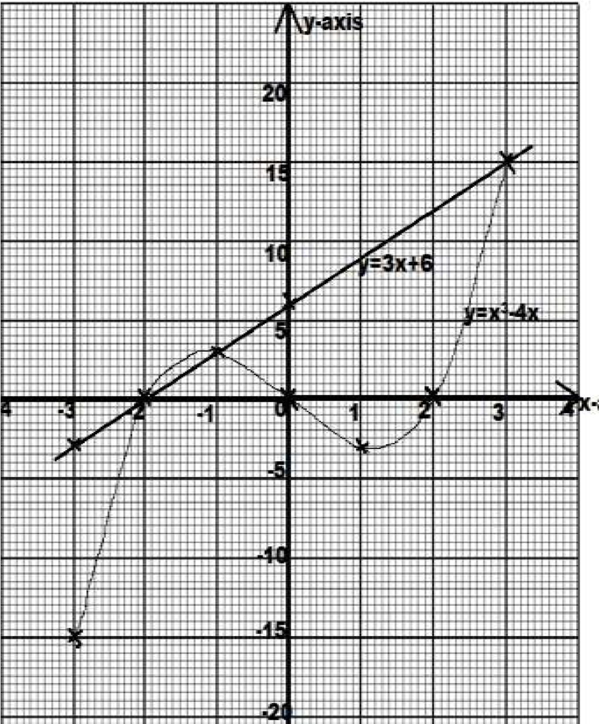
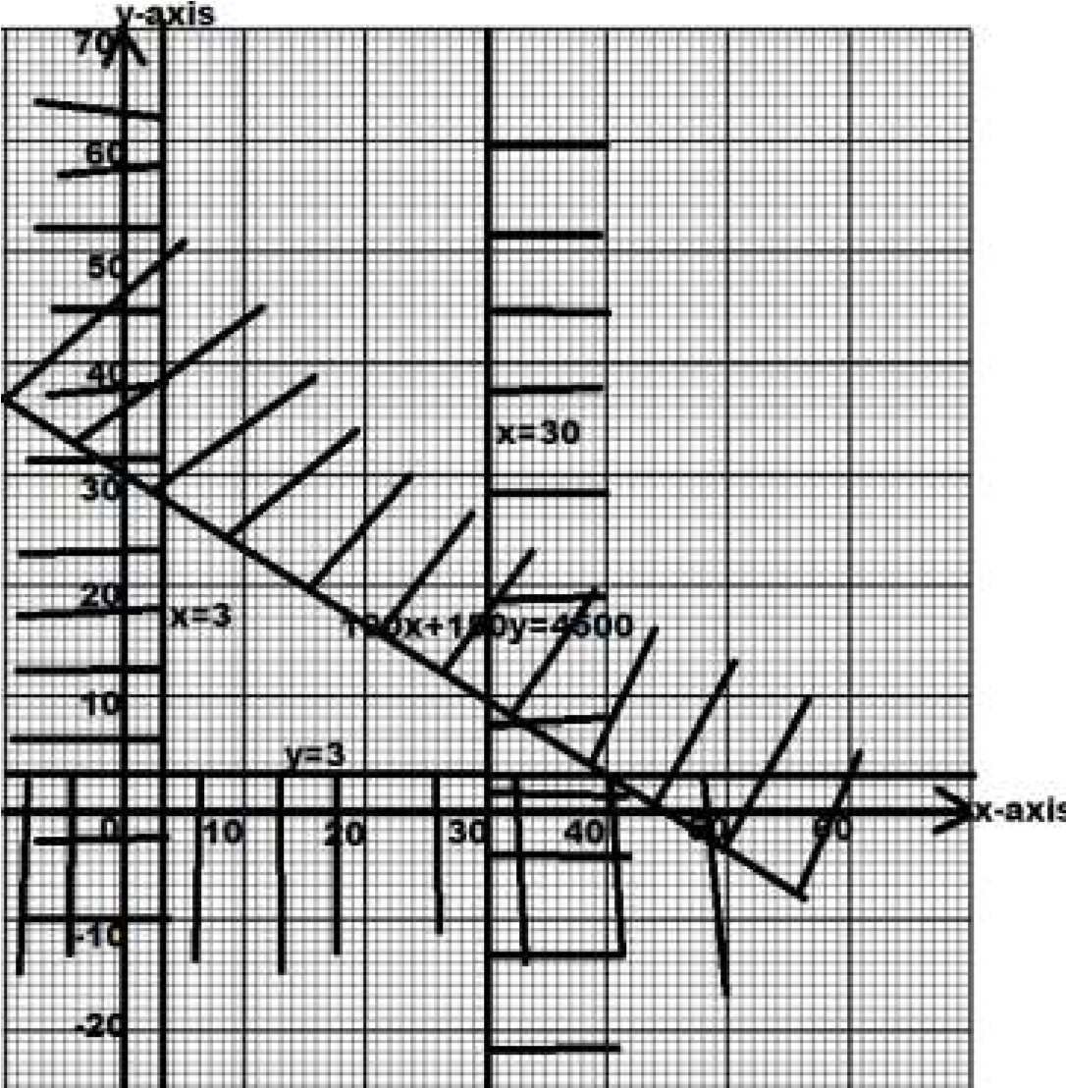

10.

11.

𝐶
=
𝑎
+
𝑘
𝑛

240
=
𝑎
+
𝑘
40

200
=
𝑎
+
𝑘
50

9600
=
40
𝑎
+
𝑘

10000
=
50
𝑎
+
𝑘

Subtracting.
−
400
=
−
10
𝑎

𝑎
=
40

9600
=
40
(
40
)
+
𝑘

𝑘
=
9600
−
1600
=
8000

𝐶
=
40
+
8000
𝑛

=
40
+
8000
100
=
40
+
80
=
120

=
𝐾
120

12.

100
𝑥
+
150
𝑦
≤
4500

𝑥
≥
3

𝑦
≥
3

𝑥
≤
30

Coners:

𝑀𝐴𝑋

𝑝𝑜𝑖𝑛𝑡𝑠
∶

(
3
,
28
)
,
(
30
,
10
)

30

+10 =

40
Fruits

END OF THE SOLUTIONS

